UPGRADE STEPS

- When you’ll import appx file EA4APIM_V2.1_BN20191130-02.appx on Embedded Analytics for API you will face below errors:
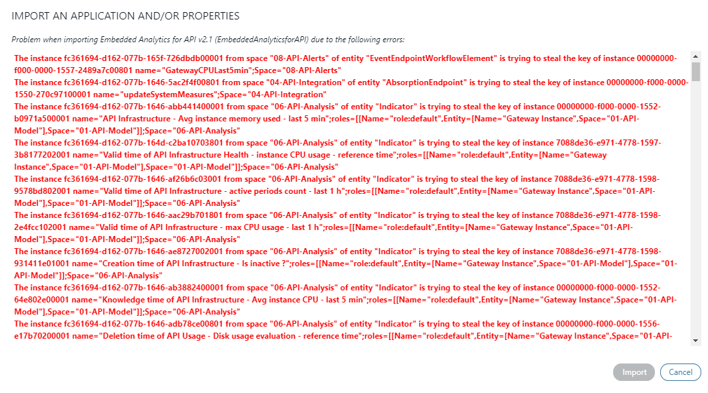

- To resolve these errors you need to remove below KPIs from the application.
Entity | Attribute
API MethodxTransaction Status | Exception thresholds
API MethodxTransaction Status | Status rate thresholds
API Method | Response time thresholds
Gateway Instance | API Infrastructure - % activity rate - last 1 h
Gateway Instance | API Infrastructure - active periods count - last 1 h
Gateway Instance | API Infrastructure - Activity indicator - reference time
Gateway Instance | API Infrastructure - Avg instance CPU - last 5 min
Gateway Instance | API Infrastructure - Avg instance memory used - last 5 min
Gateway Instance | API Infrastructure - inactivity period - reference time
Gateway Instance | API Infrastructure - Is inactive ?
Gateway Instance | API Infrastructure - max CPU usage - last 1 h
Gateway Instance | API Infrastructure - min CPU Usage - last 1 h
Gateway Instance | API Infrastructure Health - instance CPU usage - reference time
Gateway Instance | API Infrastructure Health - instance memory usage (calculated) - reference time
Gateway Instance | API Infrastructure Health - system max memory usage (calculated) - reference time
Gateway Instance | API Usage - Disk usage evaluation - reference time
Gateway Instance | CPU thresholds
Global | API Infrastructure - # Gateway instances with high CPU Usage - reference time
Global | API Infrastructure - # Gateway instances with high disk usage - reference time
Global | API Infrastructure - High CPU Usage evaluation - reference time
Global | API Infrastructure - High disk usage evaluation - reference time

- To delete these attributes, navigate to Application->Entities and click on edit for respective entities. Remove these attributes. A warning pop-up will open and click on Yes.
- After this navigate to Data Integration->Events and select space 08-API-Alerts and delete GatewayCPULast5min.
- Similarly navigate to Mappings and select space 04-API-Integration and remove UpdateSystemMeasures.
- Now go back to application and right click on EA4APIM_V2.1_BN20191130-02.appx.
- Select open archive and double click on file application.xml.
- Change the variable “partial” to false as highlighted below and save the file:
<application versionDescription="BN-20191130-01 (V2.1.2)" validTime="2020-03-16T02:51:17.671Z" valid="true" uuid="00000000-f000-0000-1545-dc3020c00001" transactionTime="9223372036854775807" platformRevision="251" platformComputingActivePeriod="days|0" partial="false" name="Embedded Analytics for API v2.1" key="EmbeddedAnalyticsforAPI" exportDate="2020-03-16T02:51:20.012Z" defaultLocale="en-GB">
- Now go back to UI and import the respective appx. It will ask you that certain attributes will be removed. Click on continue.
- After the successful import, please navigate to Data Integration->Properties and change the APPLICATION_START_DATE to 2020-01-01T00:00:00. Click on save.
- Now, start the route and verify if you are receiving the data on the dashboard.

