How to add a firewall rule using YaST2 in SuSEfirewall2

- Run yast2 command on command prompt.
- Go to the Security and Users Firewall
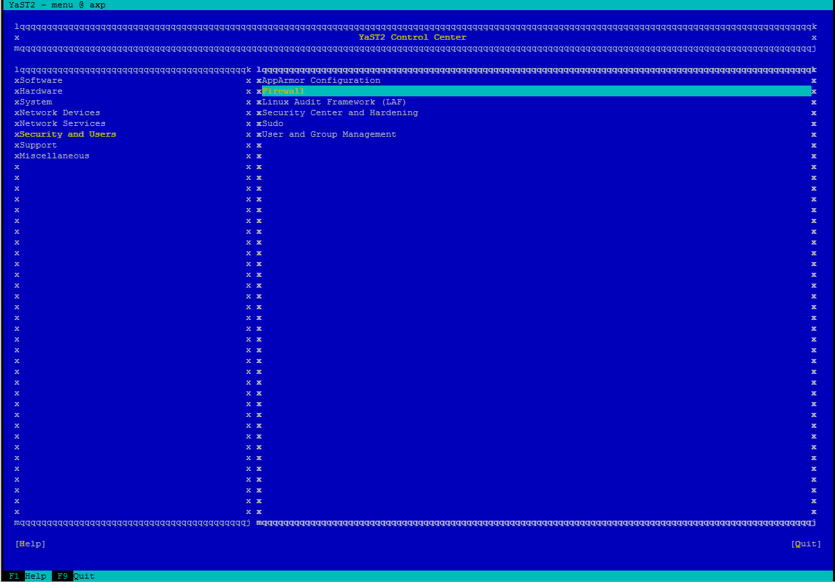

- Then, Go to the Custome Rules select Firewall Zone
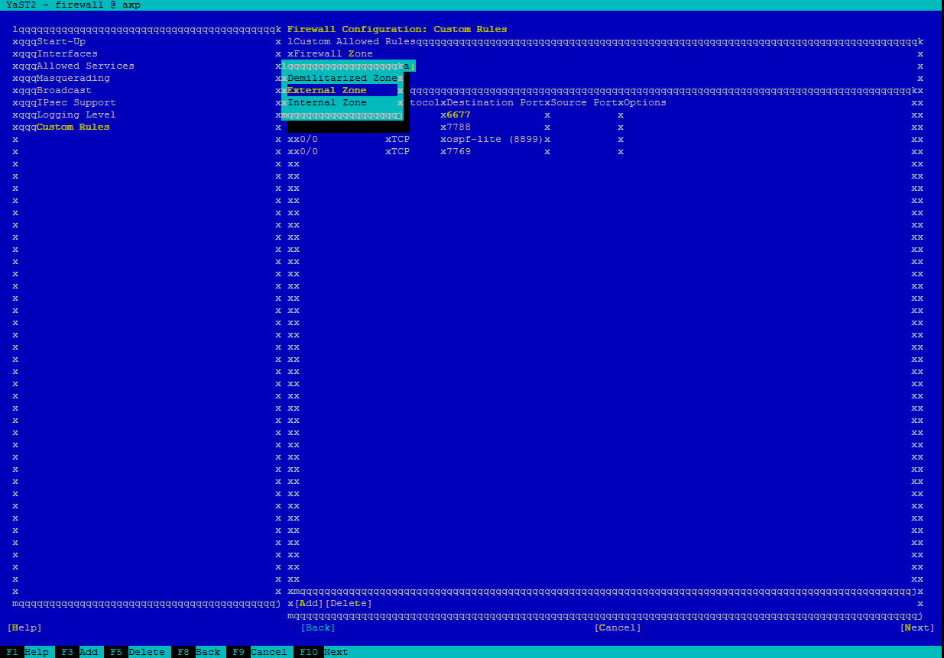

- Add firewall rule
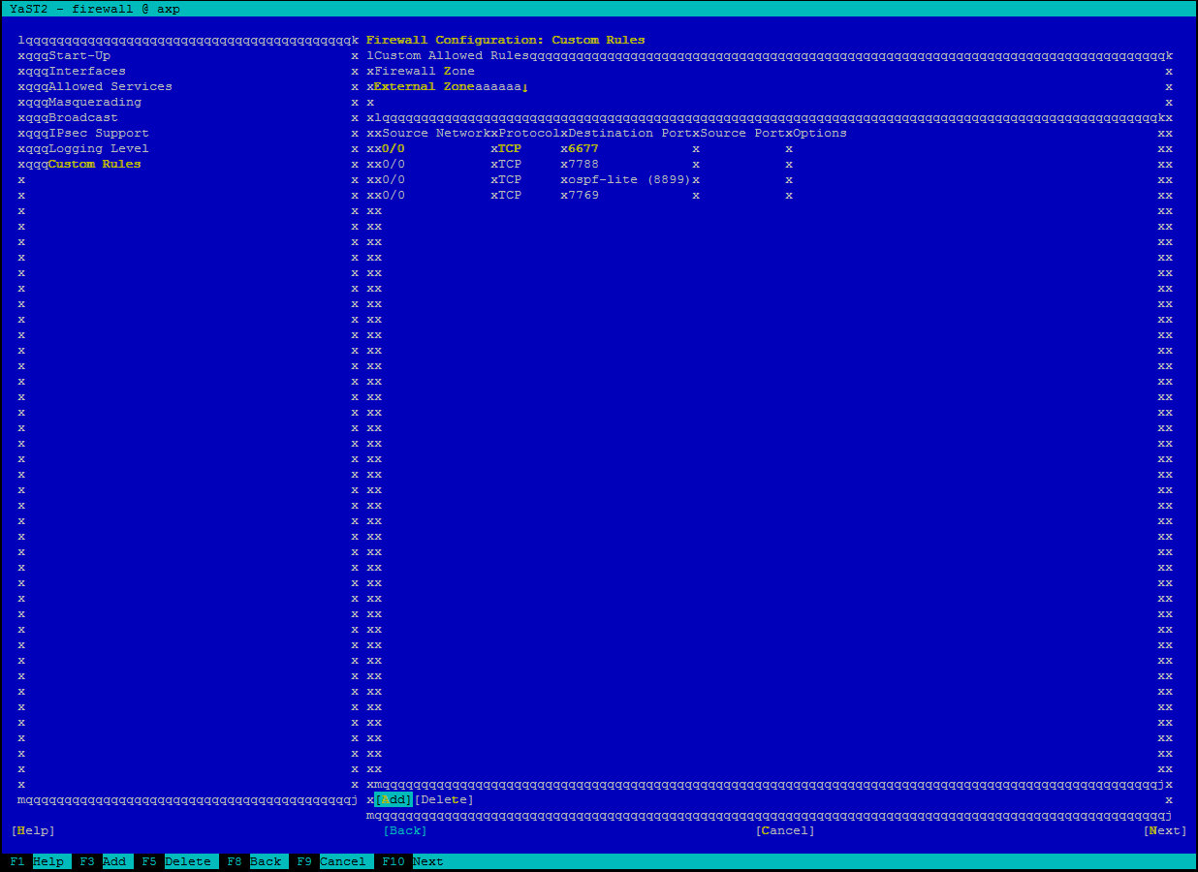

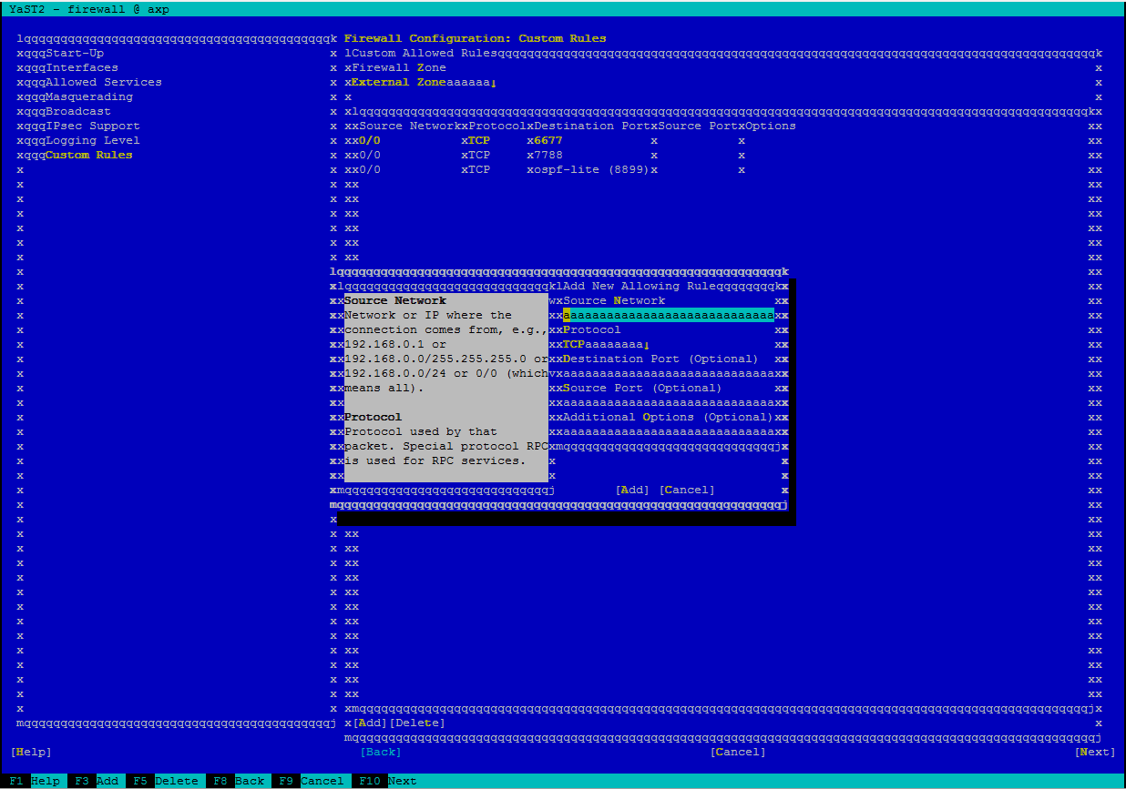

- Finish
