To create a new item / collection version in Designer it is necessary to follow the following steps:

1. Create a new object type
  - Go to: Formats -> Object Types
  - Copy the desired object type (ex. ACCDOC)
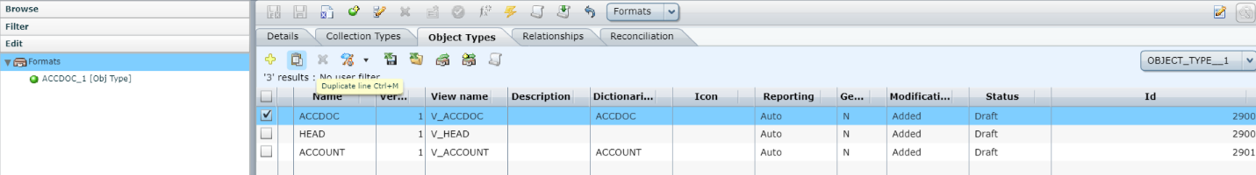

  - Change :
    - Version
    - 'Name of the DB view' - for reasons of good practice, it is called 'V_dictionaryName_versionNumber'
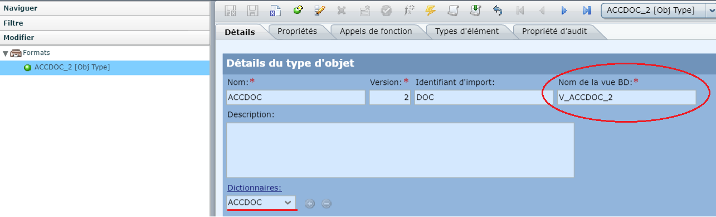

2. Creating a new type of collection
  - Go to: Formats -> Types of Collections
  - Copy the desired collection type (ex. ACCDOCSET)
  - Change :
    - 'Version'
    - 'Name of the DB view' - for reasons of good practice, it is called ''V_dictionaryName_versionNumber'
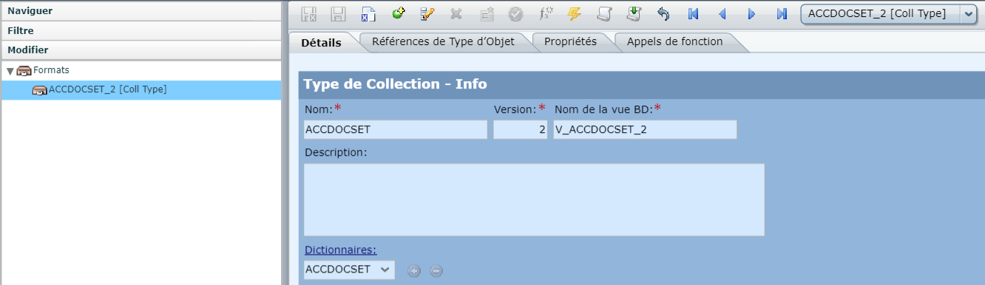

  - On the 'Object Type References' window we will have all the object type references
  - Choose the type of object you modified and change its version to be the desired version. (e.g. ACCDOC)
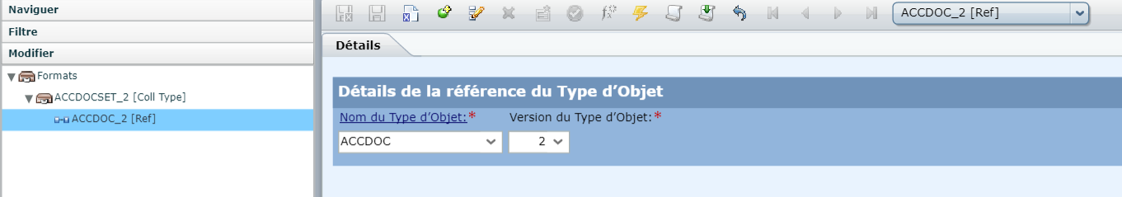

  - Return to the 'Collection Type' 'Details' window. Below you is the 'Import Service' part. In the case of 'FixedFlatFile' you must change the 'Version of CRE/ME type' to have the new version
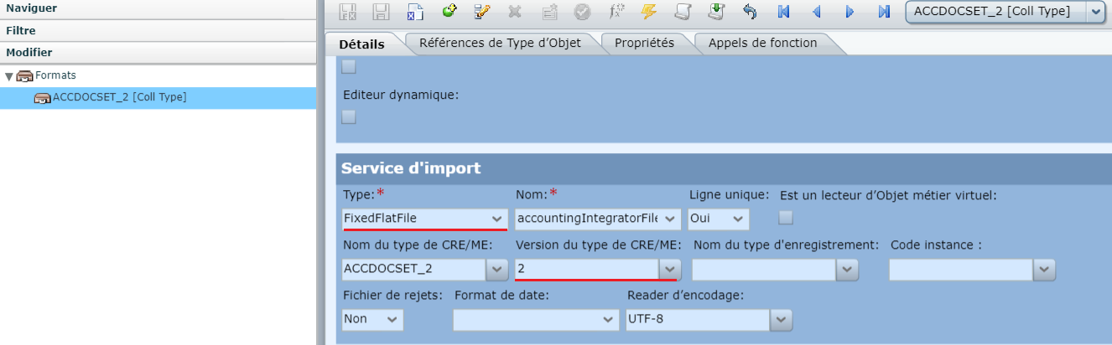

3. Creation of a new editor of object
  - Go on in: Editors -> Editors of object
  - Copy the desired editor type (eg ACCDOC_ED ) .
  - You must change (if applicable):
    - 'Item Type Name' (if you changed the name for the latest item version)
    - 'Version of Object Type '
    - 'Name' of the new object editor - for reasons of good practice it is named 'NameTypeObj_ED_noVersion'
    - 'Version' of the new editor of object
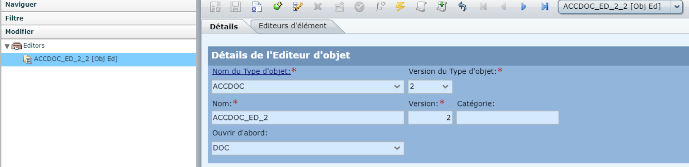

4. Creating a new collection editor
  - Go to Editors -> Collection Editors
  - Copy the type of collection editor you want (ex. ACCDOCSET_ED)
  - You must change (if applicable):
    - 'Collection type name'
    - 'Collection type version'
    - 'Name' of the new collection editor - for good practice reasons it is named 'NameTypeColl_ED_noVersion'
    - 'Version' of the new collection editor
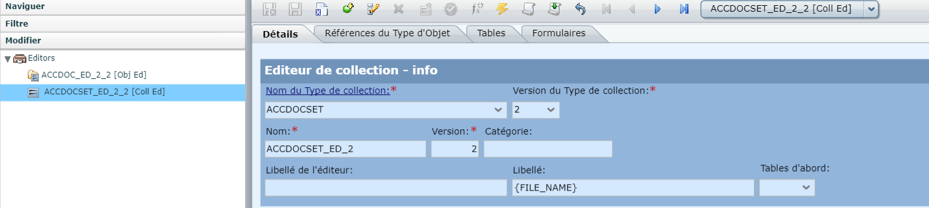

  - On the 'Object Type References' window we will have all the object type references
  - Choose the type of object you modified and change its version to be the desired version.
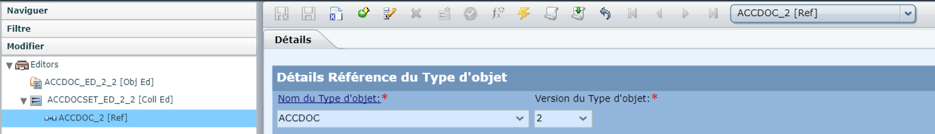

  - Go to the 'Tables' window and select the table that will have the new object editor version and change the 'Path'
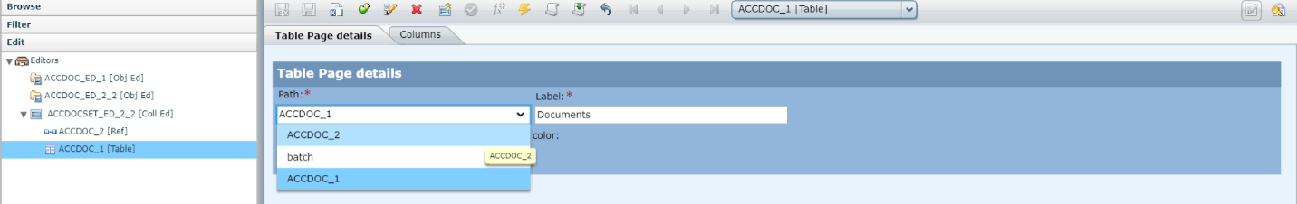

5. Creation of a new version of 'Sel. Object Editor '
  - Go to Settings -> Salt. Object Editor
  - Choose the desired 'Record Type'. Copy the desired object type. (e.g. ACCDOC)
  - You must change (if applicable):
    - Object Type Name '
    - 'Min Version Object Type '
    - 'Version max Item type' ! This detail is not marked as mandatory but you need to complete it right after the min version to have the correct list of 'Editor Object Name' details
    - ' Editor Name of object '
    - ' Editor Version of object '
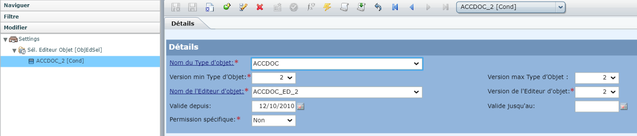

6. Creation of a new version of 'Sel. Object Type'
  - Go to Settings -> Salt. Type Object
  - Choose the desired 'Record Type'. Change the version of the desired object type. (e.g. ACCDOC)
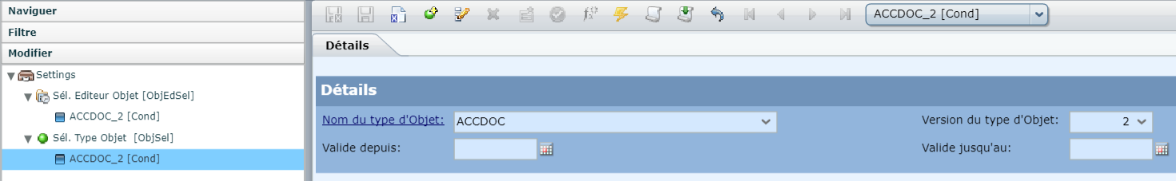

7. Creation of a new version of 'Selections Ed. Coll.'
  - Go to: Settings -> Ed Selections. Coll.
  - Choose the desired 'Record Type'. Copy the desired collection type. (e.g. ACCDOCSET)
  - You must change (if applicable):
    - 'Collection Type Name'
    - 'Version min Type of Collection'
    - 'Collection type max version' ! This detail is not marked as mandatory but you must complete it right after the min version to have the correct list of the 'Collection Editor Name' details
    - Collection Editor Name '
    - Collection Editor Version '
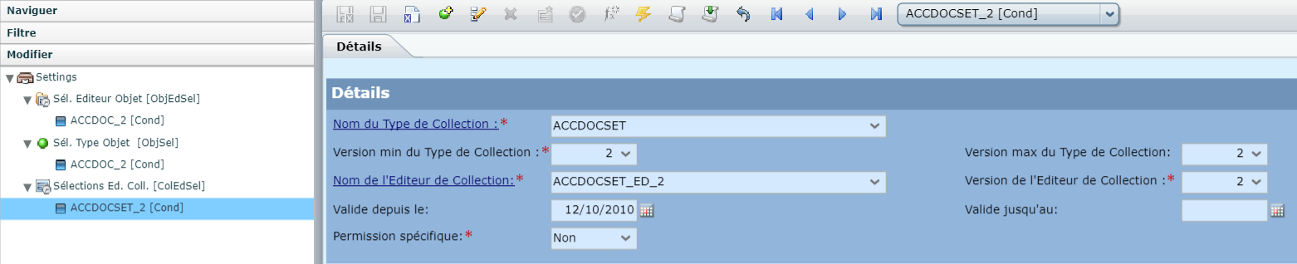

8. Creation of a new version of 'Selections type Collection'
  - Go to Settings -> Selections type Collection
  - Choose the desired 'Record Type'. Change the version of the desired collection type. (e.g. ACCDOCSET)
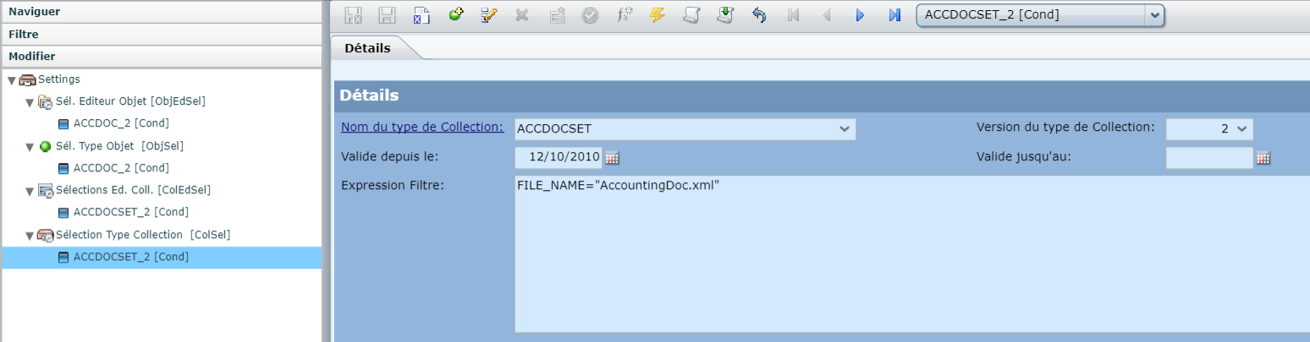

9. Deployment of the configuration

